Falaise Gap Closed
48
MILITARY
Do not perform this card unless it is the last one. If drawn prior to that place it on the bottom of the draw pile instead
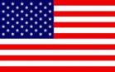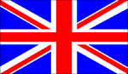
1ST US 3rd US 2ND BRIT 1ST CAN
AIR POWER
JABOS: +1 1st CAN; +1 3rd US
RESOURCES
NONE

ORDERS: 2 Actions
One free attack versus each Allied army
The Falaise gap was finally closed on August 19th with juncture of the Allied armies at Chambois, with the Poles and Americans meeting at around 19.00 Some 50,000 Germans remained trapped in the pocket, but significant numbers had escaped.

